10.58: a) From geometric consideration, the lever arm and the sine of the angle between 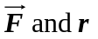 are both maximum if the string is attached at the end of the rod. b) In terms of the distance x where the string is attached, the magnitude of the torque is 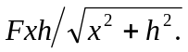 This function attains its maximum at the boundary, where 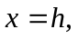 so the string should be attached at the right end of the rod. c) As a function of x, l and h, the torque has magnitude
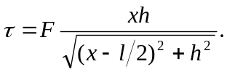

This form shows that there are two aspects to increasing the torque; maximizing the lever arm l and maximizing sin 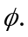 Differentiating with respect to x and setting equal to zero gives 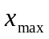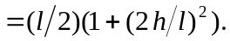 This will be the point at which to attach the string unless 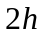 > l, in which case the string should be attached at the furthest point to the right, 